

Ngongotaha Primary School

Parent Information Booklet

2020

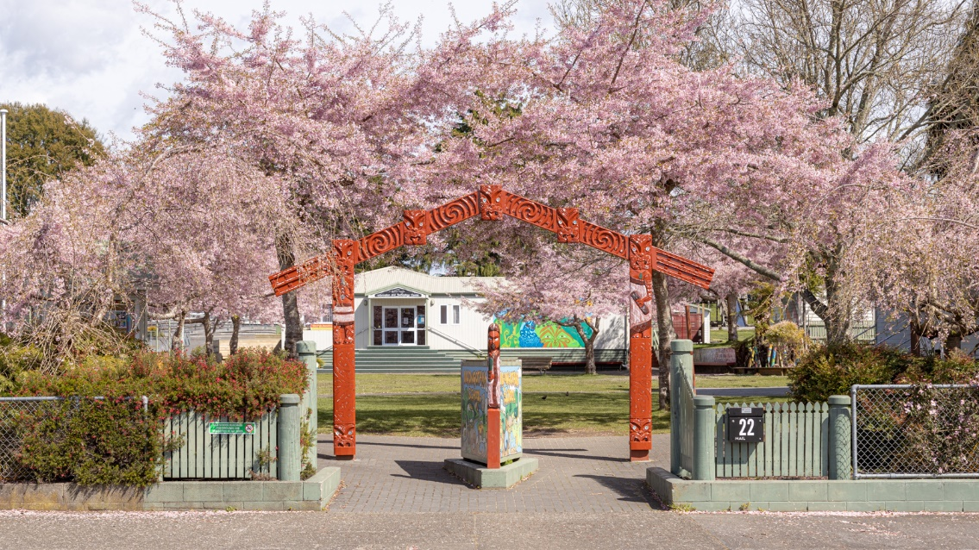

Physical Address:

22 School Road

Ngongotaha

3010

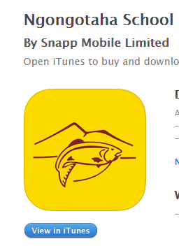https://lh5.googleusercontent.com/ScrRgvRx7BU92waKbKeOa_qzFb6-ONiF42U6koXXjKqYGqPwqb291K2kTHHG7J9fwLuRmfNInttUcbCc0iUsJGg4O_l1ridPwonwXGXh9hDNYyr-qyZf0xgj1MsCWUs0qNo5OS-a66YPhone: 07-3574531 App to download Email: office@ngongotaha.school.nz Ngongotaha School Website: [www.ngongotaha.school.nz](http://www.ngongotaha.school.nz)

Office hours: 8.15am until 3.30pm

Welcome to Ngongotaha School

To all Parents and Caregivers

It gives me great pleasure to welcome you to the Ngongotaha School whanau.

Ngongotaha school offers an exceptional academic programme complemented by numerous opportunities in sport and the arts, supporting students to explore their passions and to excel in a wide range of pursuits.

Our school roll has experienced considerable growth in recent years. We begin the year with around 350 students and finish with around 400 each year. To prevent overcrowding, an enrolment scheme put into place. Information about this can be found at the back of this booklet.

Our committed and dedicated staff hold high expectations for themselves and this is impressed upon all young people attending our school. They are a hard-working dedicated group of professionals who strive to provide quality education for every pupil who attends our school.

We are proud of our school environment, school culture and the quality of children’s learning achieved throughout the school. We aim to provide stimulating, enjoyable learning which will educate the whole child and create an independent learner for the future.

The Board of Trustees is committed to the quality education of your child and works alongside the staff to ensure Ngongotaha School is a GREAT place for you and your child / children.

All parents are most welcome to visit the school and be involved in their child’s education. Effective communication between home and school can take many forms and assists in the development and achievement of your child.

Ngongotaha School has a proud history in the community and we enjoy the community sense of whanaungatanga, belonging, that is fostered here.

We offer a range of activities, sports and interests that develop independence, perseverance, leadership and creativity. We encourage your child to take up the challenges that come their way during their time here.

We warmly welcome children, parents and all family members to Ngongotaha School and trust your transition into our school will be a happy one. We look forward to working alongside you and your children in developing a lifelong love of learning.

Mr. Craig McFadyen

Principal

**Our Mission:**

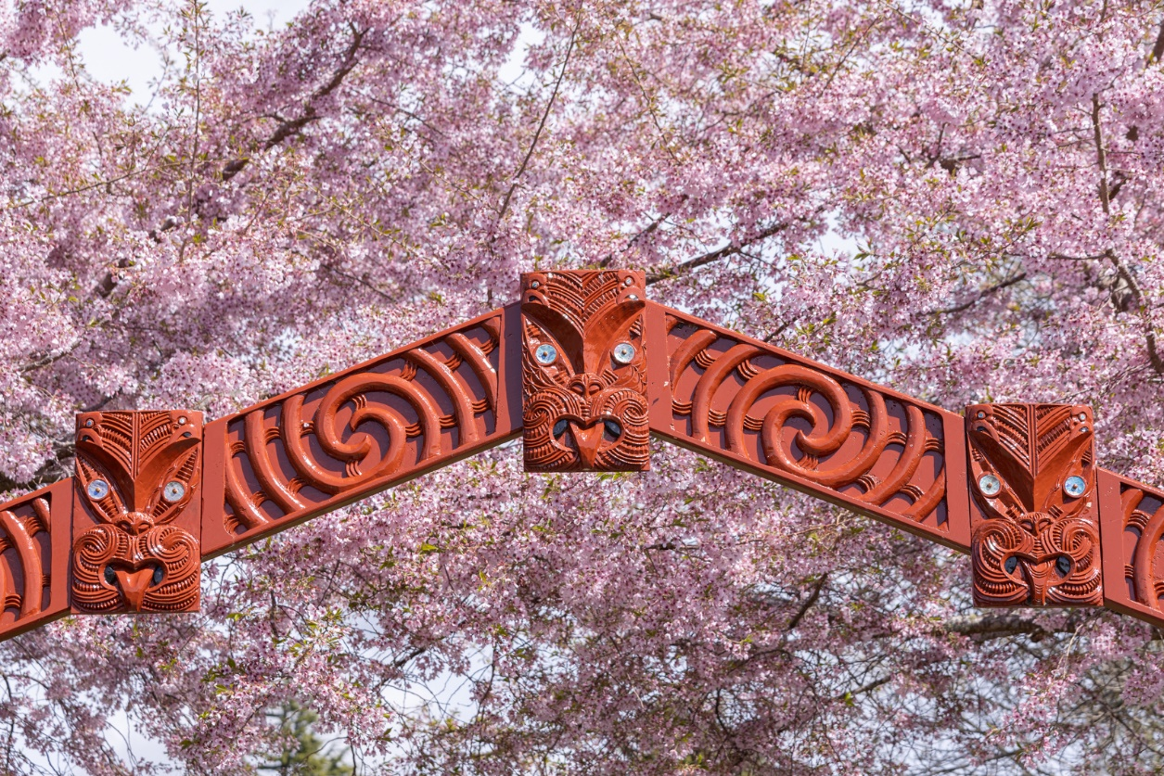

**"Aim high, stand proud"**

**"Iti rearea teitei kahikatea ka taea"**

**Our Vision:**

**Vision: We will provide quality teaching and learning opportunities to enable our students to be:**

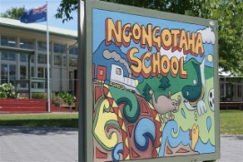**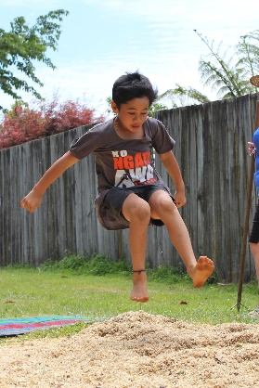 Confident:**

Be comfortable with who they are

Develop goals for themselves

Be resourceful

Be motivated and reliable

**Connected:**

Develop a positive attitude towards learning

Be caring, respectful and responsible

Be effective users of communication tools

Be responsible members of the community

**Actively Involved:**

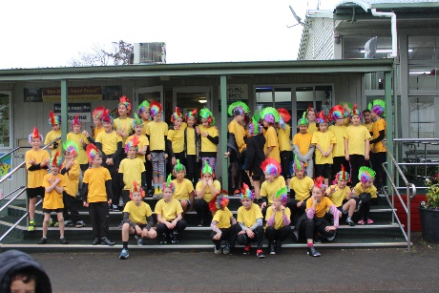Participate in a range of contexts to develop life skills

**Lifelong Learner:**

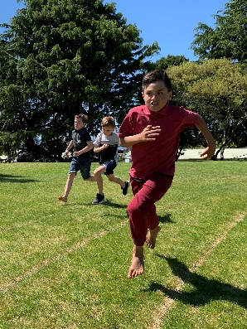Develop skills to acquire learning

Make lifelong choices – informed decision maker

Are literate and numerate

Are critical and creative thinkers

**Our Values:**

**Growth** - **Grow by having a go**

**Respect**-**Respectful, kind and caring**

**Equality** - **Everyone is important**

**Achievement**- **Are keen to succeed**

**Trust**- **Trustworthy and honest**

**T** - **Tū pakari i ngā mahi katoa**



**A** - **Awhina mai i ngā mea katoa**

**U** - **Uia mai te kōtahitanga**

**K** - **Kia whai te mātauranga**

**E**- **E whakapono, kia matatika**

**Beliefs About Learning:**

Ngongotaha School has the following core beliefs about children’s learning:

* All students can learn and have the right to do so
* Learning happens most effectively when intentions and outcomes are shared
* Students learn best when they take ownership and responsibility for their learning
* Learning is a shared experience which lasts a lifetime
* Learning is best when there is a purpose to learn
* Staff empower all students to achieve personal excellence

**BOT Members:**

The Ngongotaha School Board of Trustees comprises parent representatives, the principal and one staff trustee.

Your representatives are:

Renee Goodson Chairperson

Shaun Nunn Parent Representative

Phil Wilson Parent Representative

Joanne Edmonds Parent Representative

Debbie Hamblyn Parent Representative

Craig McFadyen Principal

Jane Nunn Staff Trustee

All members of the Board work hard on your behalf to ensure staff work in a well-resourced and supportive environment, and that we work together to fulfill the intentions of the school charter.

Board meetings are held each month on a Tuesday evening. All board meetings are advertised in advance in our Kid Zone publication. All meetings start at 6.00pm.

During 2016 we were reviewed by the Education Review Office. This report can be accessed online at the ERO site or via the link on the web page. We are looking forward to another review early this year.

The board have approved a number of property projects for 2020 and we will be reviewing our charter and the targets for the 2020 school year.

We look forward to another successful year.

|  |  |  |
| --- | --- | --- |
| **The 2020 School Year** | | |
| **Terms** | | **Public Holidays** |
| Term 1 | Monday 3rd of February  to  Friday 9th April | Thursday 6th February – Waitangi Day |
| Term 2 | Tuesday 28th April  to  Friday 3rd July | Friday 29th May- Teacher Only day  Monday 1st June – Queen’s Birthday |
| Term 3 | Monday 20th July  to  Friday 25th September |  |
| Term 4 | Monday 12th October  to  Friday 11th December | Friday 23rd of October- Teacher Only Day  Monday 26th October – Labour Day |

**THE SCHOOL DAY**

|  |  |  |
| --- | --- | --- |
| **Session 1** | 8.55am to 10.30am |  |
| **Morning Tea** | 10.30am to 10.40am | Children eat morning tea in their classes with teacher supervision |
| 10.40am to 11.00am | Children have recreation time |
| **Session 2** | 11.00am to 12.30pm |  |
| **Lunch** | 12.30pm to 12.45pm | Children eat lunch in their classes with teacher supervision |
| 12.45pm to 1.15pm | Children have recreation time, sports practices, club time. |
| **Session 3** | 1.15pm to 2.15pm |  |
| **Afternoon Break** | 2.15pm to 2.30pm | Recreation time, fruit time |
| **Session 4** | 2.30pm to 3.00pm |  |

# SCHOOL MAP

# 

**Staffroom, Sickbay, Rooms 1, 2, Ngati Whakaue, 3 & 4 Rooms 5 & 6**

**Office, Principal, AP**

**Resource Room,**

**Rooms**

**7 & 8**

**Library**

**ICT Suite**

**Pool**

**Front entrance Whare Waananga**

**PE Shed Rooms**

**10, 11, 12 & 13**

**Room**

**9**

**AP Room 14 & 15 Office**

**Office**

**Court – Turf**

**Room 16**

**Room 17 Caretaker**

**TRANSITION TO SCHOOL - Getting ready for school.**

* Enroll your child at the school office. You will need to have the birth certificate or passport, immunisation forms. You can do this at any time before your child is due to start school.
* You will be given some forms to read and sign. Please fill these out and return them to school.
* On the day your child starts school, you need to come to the school office, before going to your child’s classroom, so that the enrolment process can be completed.
* It is important that all your child’s belongings are named: shoes, uniform, togs, towel, lunch box and bag.
* You can purchase stationery before your child starts school, this is available online by going to myschool.co.nz then search for Ngongotaha School or by visiting OfficeMax stores.
* Uniforms can be purchased at “The Warehouse”. A small supply of some second-hand items can be purchased from the office.

**GREAT START Programme**

This consists of a five afternoon induction to school programme spread out over five weeks. All children entering school within the term (and the following two weeks of the next term) can come on the GREAT start visits that are held on Tuesdays from 1.15pm to 2.15pm, weeks 3-7 of each term, for mainstream children, and Wednesday 8.45am to 11.00am for children who wish to enter the Rumaki classes. (Please contact the school office for the dates)

* **Week Three:** Introduction to school, parent questions, meet the principal, walk

around the school and some activities related to school life.

* **Week Four:** Oral Language
* **Week Five:** Literacy (reading and writing)
* **Week Six:** Numeracy, maths
* **Week Seven:** A visit to the classroom that your child will be joining, meet the

teacher and the other children.

You are welcome to stay at school for the afternoon break so that the children can play on the playground with the other children.

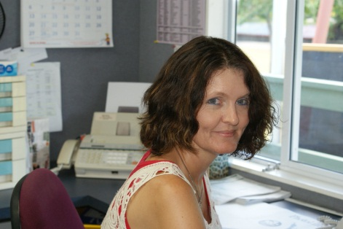

**ENROLMENTS**

* Are completed by the School Office Manager, Julie Roker, through the Office.
* Once processed, parents and new arrivals are introduced to the Principal who, in consultation with the Associate Principal, will complete class placement.
* On enrolment, please inform us of any issues that may be a factor in your child’s schooling. We are more able to provide appropriate programmes when we are informed.

**NEW ENTRANTS (Enrolled on 5th birthday).**

**We require the following:**

* A birth certificate or passport is required with all New Entrant 5 year olds.
* Immunisation Certificate (available from your doctor) or B4 School Check records.
* Parents are required to sign the enrolment form as an expression of acceptance of school rules and / or regulations.

**PREPARING FOR SCHOOL**

* Be on time – social things happen before school and children who come late miss out on this time to meet with the teacher and friends.
* Have the correct gear – a correct school uniform, stationery and lunch enables your child to settle each day. Encourage independence and self-organisation.
* Have a positive attitude – encourage your child to try hard and have a positive attitude to school. Encourage your child to help pack their own school bag.

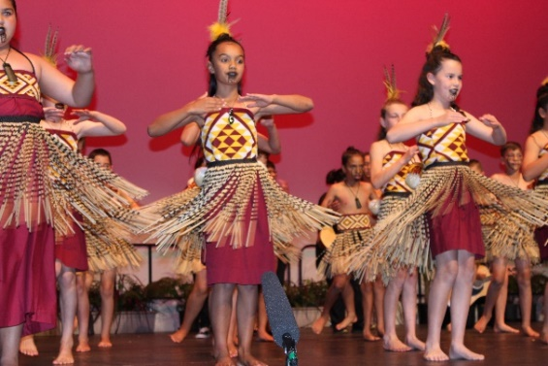

**RUMAKI - TE REO MAORI – PROGRAMME**

* For those parents who wish their children to be in a class with a greater emphasis in Te Reo and Tikanga Maori, an opportunity exists for children to be enrolled in the Rumaki Units.
* Children who have ability in Maori Language and attendance at Kohanga Reo will be given priority. Parents should be aware that the level of immersion is between 80% and 100%. This means the class programme will be in Te Reo Maori for the majority of the time. Children will be encouraged to take this knowledge into the playground with them.
* We do run a GREAT start programme for children in our Rumaki programme. This programme is run along the same format as the mainstream induction programme but is worked in Te Reo Maori and runs on a Wednesday morning from 8.45am to 11.00am. Please call into the office to discuss this. If you require further information, please arrange an appointment with Tamara Simpkins –Associate Principal.
* Whanau Hui will be held each term so that communication is maintained. Class

programmes, school direction and current professional development will be covered at these hui. We look forward to your involvement in your child’s schooling and the life of the school.

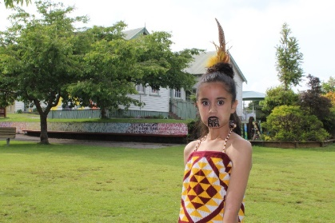

|  |  |  |  |  |
| --- | --- | --- | --- | --- |
| **School Organisation** | | | | |
| **Principal:** Mr Craig McFadyen | | | | |
| **Associate Principal:** Mrs Tāmara Simpkins  **Associate Principal:** Mrs Alison Astwood | | | | |
| **Area** | **Year** | | **Room** | **Teacher** |
| Te Whanau Manu | 6 & 5 | | 3 | Mrs Jae MacFarlane- Team Leader |
|  | 6 & 5 | | 2 | Mr Stuart Drewe |
|  | 6 & 5 | | 4 | Miss Jamie Thompson |
|  | 6 & 5 | | 1 | Mrs Jane Nunn |
|  |  | |  |  |
| Te Whanau Wai | 4 | | 7 | Mrs Pam Rogers - Team Leader |
|  | 4 | | 16 | Miss Carolyn Fraser |
|  | 3 | | 9 | Mrs Sue Hughson |
|  | 3 | | 8 | Mrs Alison Astwood |
|  |  | |  |  |
| Te Whanau Ngahere | 0-1 | | 14 | Miss Amy Wadsworth - Team Leader |
|  | 2 | | 13 | Miss Lesley McCauley |
|  | 2 | | 12 | Mrs Tayla Ua-Lindebaum |
|  | 2 | | 11 | Mrs Stevee Raureti |
|  | 1 | | 10 | Miss Mackenzie Muncaster |
|  | 1 | | 15 | Mr Nigel Hendra |
|  |  | |  |  |
| Te Whanau Maunga | 6, 5 & 4 | | 5 | Miss Tawi Roberts- Team Leader |
|  | 3, 2 & 1 | | 6 | Miss Kahurangi Hodge |
|  |  | |  |  |
|  | Reading Recovery | | 17 | Mrs Ana Te Whata Jacobs |
|  | | | | |
| Specialist Teachers | | Mrs Rosalie Palmer – Choir | | |
| Class Release | | Miss Kylie Coles – Room 8 | | |
|  | | Mrs Jenny Pollard- Beginning teacher release | | |
|  | | Mrs Teneille McFadyen- Senior teacher release | | |
|  | | Mrs Carol Lunt- Teacher release | | |
| Teacher Aide | | Mrs Shiona Wenborn | | |
|  | | Mrs Jacqui Stevens | | |
|  | | Mrs Kim Hirst | | |
|  | | Mrs Emma Cullen | | |
|  | | Mrs Ana Flavell | | |
|  | | Mrs Ange Ryan | | |
|  | | Mrs Shanell Hopkins | | |
|  | | Mrs Megan Wynyard | | |
| Kaiawhina | | Mr Wiremu Vercoe-Roberts | | |
| Office Manager | | Mrs Julie Roker | | |
| Administration Manager | | Mrs Jocelyn Mear | | |
| Resource Manager | | Mrs Elaine Whyte | | |
| Librarian | | Mrs Lyn Le Lievre | | |
| PE & Sports Programmes | | Mrs Donna Ngatai | | |
| Caretaker | | Mr Doug Simon | | |

**ATTENDANCE** (appendix 1 truancy protocol)

* The Ministry has placed much emphasis on attendance in their efforts to address student achievement. For most children “Attendance = Achievement”. We have procedures in place to monitor and track attendance at school.
* Regular attendance at school is fundamental to student learning. Students who attend school regularly are more likely to achieve educational success, and increase their career and life options.
* At Ngongotaha School each child has an attendance graph, on display in the class, so they can track their own attendance and so you can see at a glance how their attendance is going.
* The following Ministry of Education definitions are provided to help schools classify each absence.

Justified absence - Absence that is explained to the satisfaction of the Principal. Examples of justified absence include medical appointments, illness, bereavement, personal or family circumstances.

Unjustified absence - Absence that is either unexplained, or not explained to the satisfaction of the Principal.

Intermittent unjustified absence - Absence that is periodic – that is, where a student is late to class or misses part of a period or a full school day, with no justified reason.

Truancy - The total of all of a particular student’s unjustified and intermittent unjustified absences.

Frequent truancy - Truancy that occurs three or more times in any one week.

* Included with this information booklet is a copy of the procedure for non-attendance.

**ABSENCES**

* It is essential, in today’s climate, that we know where our pupils are on any given day. If your child is not attending school, for any reason, please phone the office **ANSWER PHONE** facility and leave specific details or text the school on Mobile phone **027 675 7565** with an explanation. You can also send a message via the school app which can be downloaded to your phone.
* Office staff will ring parents, at home or work, if absence is noted and no reason has been received. If we cannot contact you the absence will automatically be recorded as truant. This can be changed if an explanation is provided.
* Upon return, your child should hand a letter of explanation (for absence) to the class teacher.
* Staff complete a register of attendance twice each day – morning and afternoon. If children are absent this is recorded and followed up through the office.

**LATENESS**

* School starts at 8.55am. If your child is late, please ensure they come to the office first so they can be checked off the absentee register. Regular late comers are monitored and liaison with families will be initiated. Children need to be in school by 8.45am to prepare for the day’s work.
* If collecting your child from his/her classroom, please wait outside until the class teacher has dismissed the children.
* If your child is being picked up during the day, please come to the office and sign

him/her out, if he/she returns later in the day please call back into the office.

**ILLNESS or ACCIDENT AT SCHOOL**

* In the event of your child becoming ill or injured at school the office will contact you to collect your child. If a child cannot be collected, he/she will be cared for in our medical room. It is most important that families update any changes in home circumstances – telephone numbers, change of address, mobile numbers and after school arrangements. In times of emergency we need immediate access to accurate information.

**MEDICATION AT SCHOOL**

* If your child requires any medication, on a daily or regular basis, you are required to complete a parental consent for assistance in administering drugs form. This is held in the school office.
* C:\Documents and Settings\cathryn\Local Settings\Temporary Internet Files\Content.IE5\G2AGULHN\MC900293316[1].wmfAny medication will be administered by Mrs. Julie Roker, Mrs. Elaine Whyte or Mrs Joss Mear, through the school office.
* If your child suffers from asthma, we hold their pump or spacer in the office or medical room. Please ensure you check expiry dates on a regular basis. We will check these at the end of each year and follow up with parents.
* No medication is administered without parental consent.

If your child brings medication, for a short period, it needs to be handed into the office and collected each day. This will be administered by office staff, not classroom teachers.

**STATIONERY REQUIREMENTS**

* Stationery is purchased online by going to **myschool.co.nz.** Enter the name of the school, you can then search for your child’s class and complete your order. The stationery can be posted directly to you or you can go into Office Max, on Fenton Street, and collect it. Alternatively, you can go into the store, give them the name of the school and room and they will complete your order for you.
* C:\Program Files\Microsoft Office\Media\CntCD1\ClipArt2\j0232149.wmfThe office will have a limited supply of stock for sale this year.

**VOLUNTARY DONATIONS**

* We do not ask for school donations here at Ngongotaha School. There is, however, times when we ask for a donation to cover the cost of an overnight trip such as noho Marae or school camp.
* For any payments, an EFTPOS facility is available to make payments. Direct payments can also be set up, please call in and see the Executive Manager, Joss Mear, if you wish to follow this up. **Immediate payment would be greatly appreciated.**

**School Bank Account: 03 1545 0008410 000**

Always reference with your child’s full name and reason for the payment.

eg. John Smith Touch Rugby Fees

**PARENT HELPERS**

* We welcome your support for our class programmes and your child’s education. Please see your child’s teacher to discuss how you can provide support and assistance, at any time.
* If you are interested in volunteering in class, please discuss how you might assist with your child’s class teacher.

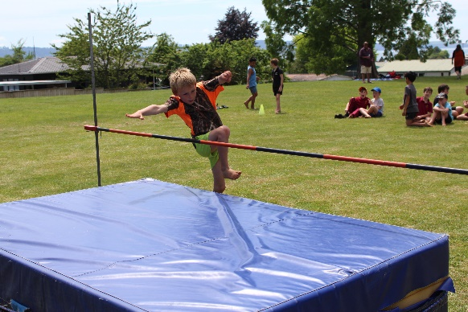

* In anticipation of your help - sincere thanks!

**SCHOOL UNIFORMS**

* The Board of Trustees has resolved that the school uniform is compulsory for all students.



* The uniform can be purchased from **“The Warehouse”** which is situated in the Rotorua Central Mall.
* Long trousers and polar fleeces are available for when the weather turns cooler.
* Any suitable footwear, that comes off and on easily, is acceptable. All classrooms have shoe racks for shoe storage during the day.
* We do have some items of second hand uniform, if interested please ask at the office.
* We encourage students to wear a sun hat during the summer months. There is no specific school hat for this.

* Please ensure all clothing is named, including shoes, togs and towel (during swimming months).

* Some earrings can be extremely dangerous in the school environment. To ensure our students remain safe from accidental injury while playing, parents are asked to monitor the type or earring worn by their child.
* In winter terms, we allow our students to wear tights/thermals under their uniform. These must be plain black.

**SCHOOL LUNCHES**

* We are very lucky to be a part of the Government’s Free Healthy Lunches Pilot this year.
* All children will receive a free lunch each day of the week.

**LOST PROPERTY**

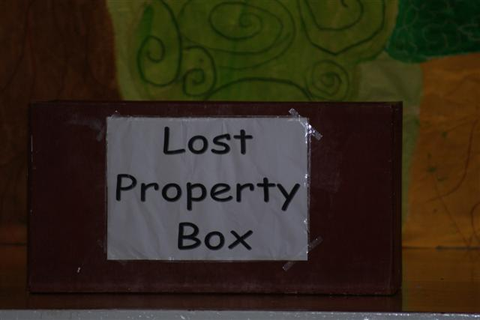

* Children need to develop an independent responsibility for their property. Please take time to name all of your child’s clothing, including shoes, togs and towel during swimming months.
* Lost property boxes are located in the building behind the Whare Waananga.
* This shed is open before school and all day and is locked when the road patrol finish their role at the end of the day.

**KIDZONE**

* This school newsletter publication will go home each fortnight on a Thursday. The Kidzone includes messages from the principal, student work, photographs, staff messages and, if there is space, community notices. It is also loaded onto the school website and app each fortnight.

**DENTAL SERVICE**

* We have a mobile dental clinic on site to deal with the everyday needs of our children. This will be for one term each year and the Kidzone will inform you when it is on site.
* For dental service, when the mobile clinic is not on site, **phone 027 5110152**

**CYCLING TO SCHOOL**

* The law requires every cyclist to wear an approved safety helmet.
* Please ensure your child has suitable locking facilities for their bike.
* Bike racks are located beside the Whare Waananga in view of the school office.
* We ask that children walk their bikes within the school grounds.

**SCOOTERS**

* If your child comes to school on a scooter they should be wearing a helmet. We have scooter racks at school which children can lock their scooters to.
* Scooters are not to be ridden in the school grounds.

**TRAFFIC CONTROL**

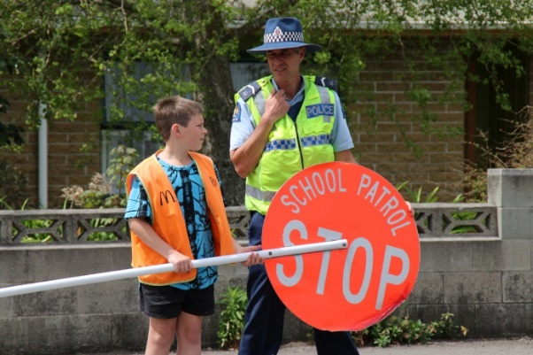

* Senior students, carefully selected and trained by Police Officers, control the school crossing from 8.20am until 8.40am and again from 2.55pm until approximately 3.15pm. They are also supported by a staff member.
* Parents are asked to **Respond** to their signals in a polite and courteous manner.
* Their one purpose is to provide a **SAFE ENVIRONMENT** for your children.
* We ask that you do not park on the dotted yellow lines, beside the crossing, as this hinders the students ability to see oncoming traffic.

* Traffic Officers ensure that parents respect the parking laws. Regular random checks are carried out.
* We ask that you do not park in the Kindergarten parking area unless you are picking up a child who attends the Kindergarten.

**SCHOOL BUSES**

* Please enquire in the office about your child’s eligibility for bus transport. Approximate bus pick up times are available directly from the bus company providing the service.
* A high standard of behaviour is expected while waiting at bus stops and travelling, bus wardens will be monitoring and reporting back to the school.
* Children who travel on a bus are to remain in the school grounds at the end of each day. A bus bell will ring at 3.25pm at which time all children will assemble at the Whare Waananga. Bus monitors will complete a roll check which duty staff will check. If it is wet, bus children will remain in their own class until the bus bell rings.
* C:\Documents and Settings\cathryn\Local Settings\Temporary Internet Files\Content.IE5\W2BA6BAA\MC900134537[1].wmfConcerns about buses are to be directed, in the first instance, to your child’s teacher who will follow this up with leadership staff.
* If you collect your child after school, and they are not travelling on the bus, please ensure his/her absence is recorded in the appropriate Bus Book held in the office.
* Misbehaviour on the bus may result in the service being withdrawn from your child. If this occurs the school will make contact with you to follow this up.

**LEAVING SCHOOL GROUNDS**

* No child will be permitted to leave the school grounds during school time or the break times without permission from the class teacher via prior parent arrangement.

**AFTER SCHOOL ARRANGEMENTS**

* Please ensure you and your child make any arrangements to go to friends’ homes after school, before they come to school in the morning. Children will not be permitted to do this from the office at the end of the day. They must go home first and organise this with you.
* Children waiting to be picked up, at the end of the day, are to wait on the verandah of the staffroom. All children should be picked up before 3.20pm.
* If you are running late please phone the office as the children do get anxious when waiting.

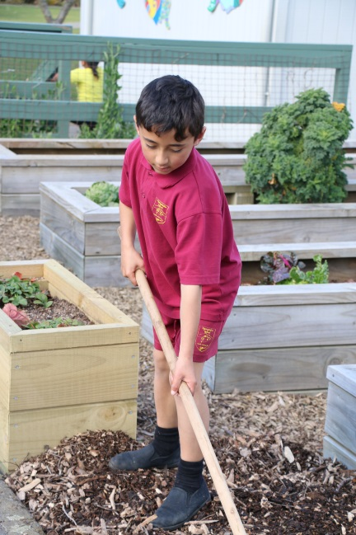**AFTER SCHOOL CARE**

* A service is provided by Ngongotaha Out of School Care Programme and is based in the Community Hall. Registered children are collected from school each day and walk to the community hall where they are supervised until pick up. We have information forms in the office. This service is not a school based service.

**GARDENING CLUB**

* We have an active group of students who work with Whaea Shiona in the gardening club. This group take care of the school vegetable gardens behind the library.
* If your child is keen to become involved in this get them to see Whaea Shiona.

**NGATI WHAKAUE PROGRAMMES**

* Through the generosity of the local Ngati Whakaue Education Endowment Trust, this school receives additional funding to provide additional literacy or numeracy instruction and support for Māori students.
* This year, the funds will allow us to enhance literacy skills of children in the year three and four cohort. Mrs Alison Astwood will oversee our Teacher Aides facilitate this programme which will run each morning from 9.00am to 12.30pm. If your child is part of this programme, Mrs Astwood will make contact with you.
* These programmes are overseen by the leadership team. If your child is part of these programmes we encourage you to come in and discuss your child’s progress at any time.
* Milestone reports are completed twice a year which are sent to Ngati Whakaue Education Endowment Trust and to the School Board of Trustees.

**SUPPORT PROGRAMMES**

* At Ngongotaha we endeavour to provide assistance to those students who are in need. These programmes are supported, and frequently funded, by the Board of Trustees.
* We also utilise the RTLB (Resource Teacher of Learning and Behaviour) service and the RT Lit (Resource Teacher of Literacy) service as the need arises.

**SOCIAL WORKER IN SCHOOL – SWIS**

* We are fortunate to have a social worker available to you if the need arises. Alison Ririnui is at school each Monday, Tuesday and Wednesday. Her office is located beside Room 14.
* Alison provides excellent, confidential, service to the school community and is very approachable.

**LIBRARY**

C:\Documents and Settings\cathryn\Local Settings\Temporary Internet Files\Content.IE5\0NTQLZ29\MC900198771[1].wmf

* We have a well-resourced library on site for students. Mrs. Lyn

Le Lievre, the librarian, has a wealth of knowledge and is available to parents who wish to discuss reading material for their children.

* Each year student librarians are trained to provide assistance in the library and to develop library skills for themselves.





**INFORMATION & COMMUNICATION TECHNOLOGY**

* We see the use of technology within the classroom as another form of learning. This year we are working hard to ensure we have devices and infrastructure to ensure the children are able to be global learners.
* The school also uses chromebooks, desktop computers and iPads to enhance learning in the classroom. These are available for staff and student use.
* Cyber Safety agreements will be sent home on enrolment for your signature. This covers the use of the internet and the production and presentation of photographic material.

**SWIMMING POOL**

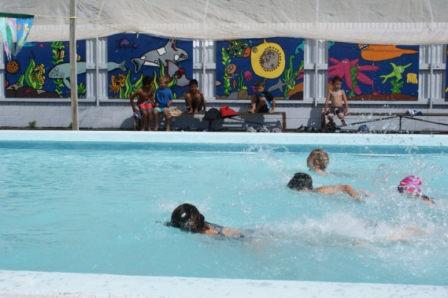

* The solar-heated Learners’ Pool is available to all classes in Term 1
* Swimming is an integral part of our Physical Education Programme and a component of the New Zealand National Curriculum and accordingly every child will be expected to participate fully.
* Junior children are timetabled to swim in the afternoon, when the air temperature is warmer.
* 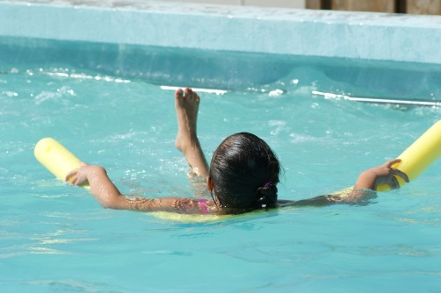With so many opportunities for Rotorua children to be in or around water it is essential that children have water confidence. Please support the school swimming programme. You are more than welcome to attend your child’s pool sessions at school to see how they are doing and discuss any needs they may have.
* 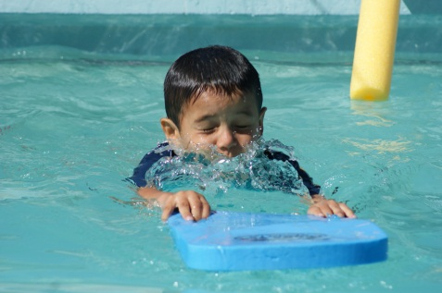Some children may benefit from swimming instruction through outside agencies. Feel free to discuss this with your child’s teacher as they will be able to advise you of your child’s confidence when swimming at school.

**LEARNING**

* Each class will provide a balanced programme covering all areas of the New Zealand Curriculum or Te Marautanga o Aotearoa. Curriculum learning objectives are set each year and are based around school wide themes.
* The New Zealand Curriculum gives schools direction for learning through vision and guiding principles. Key learning areas; English, The Arts, Health and Physical Education, Mathematics, Science, Social Sciences and Technology are taught with the integration of values and key competencies.
* Children can learn in a variety of approaches and styles and teachers endeavour to deliver motivating and stimulating programmes that assist students to develop and enjoy their learning.

**CHILDREN’S PROGRESS and ACHIEVEMENT**

|  |  |
| --- | --- |
| **TERM 1** | Parent BBQ evening to discuss the year overview, consult about aspects of school and outline class procedures. |
| **TERM 2** | Interim progress reports are sent home for children. |
| **TERM 3** | School/Whanau discussions. These take 10 minutes and are a formal time when parents can discuss their child’s learning progress and needs. Children are invited to attend these discussions. |
| **TERM 4** | End of Year achievement report. If you wish to discuss any aspect of this report you can arrange a time with the class teacher.  School/Whanau discussions. These take 10 minutes and are a formal time when parents can discuss their child’s learning progress and needs. Children are invited to attend these discussions. |
| An “open door” policy exists for parents, being aware that all teachers are responsible for teaching 9.00am to 3.00pm. Any issues can be addressed by meeting outside of these times or by arranging a suitable time with the class teacher. | |

**ASSESSMENT**

* Children are assessed regularly to monitor progress and identify learning needs. A range of methods and strategies will be used to gather information.
* Children are tested on entry to school, and again at 6 years of age, in basic literacy and numeracy. Interviews are set up after each of these assessments to discuss findings and programmes with families.
* The assessment carried out at entry and 6 years is also carried out in Te Reo Māori for students who have their education in this medium.

**HOMEWORK**

* Parents want to be a part of their child’s education and this can be done through a number of ways.

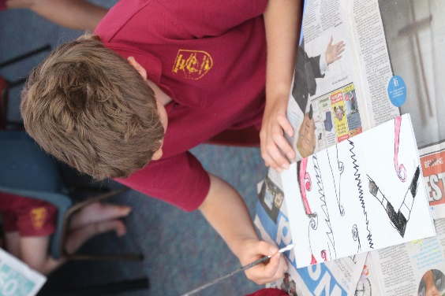

* Developing oral language is a critical factor for children and we encourage you to have regular conversations with your child about their learning. Encourage them to speak in a sentence, ask and answer questions, and talk to them as you are carrying out household activities like cooking, shopping etc. Explain to them what you are doing so they develop the language specific to these tasks.
* In the early years children will bring reading material home to support class instruction. This can be read to, with, or by the child in a positive manner.
* Reading to your child regularly will assist in the development of word knowledge and vocabulary.
* Class teachers and the school librarian can recommend a range of books that can be read to children.
* Number knowledge is vitally important to numeracy development. In the early years being able to count from 1 to 10 in the correct order, make sets to 5, recognise numerals to 5, know basic colours and shapes and ability to sort by colour, shape or size can be extremely beneficial to your child’s maths development.
* Teams will have various other activities to support learning at home and these may change depending on the class unit of work or theme.
* Feel free to meet with your child’s teacher to follow up any questions you may have.

**SCHOOL ASSEMBLIES**

* Assemblies are held on Fridays at 9.15am in the Community Hall—across the road from school, weather permitting.
* Classes take turns hosting the celebrations and we always recognise good behaviour by awarding books to children who are CAUGHT BEING GREAT!

Without doubt, these awards provide a very positive platform on which to encourage

appropriate behaviour and to acknowledge positive role modeling.

* Every assembly acknowledges the Library Award (for best behaved class using this facility), the Tidy Kiwi Award (for the best kept classroom) the Sports Award (for the best behaved class at Physed) and Brainy Awards (for academic development and achievement).
* Principal certificates, commonly known as “FISH Certificates”, are awarded once a child has 30 stickers on their class fish. These stickers are awarded for appropriate behaviour, good work ethic, achievement, progress, use of te reo and evidence of our GREAT values in action.
* Values vouchers awards are presented each assembly. These are awards for recognition of GREAT playground behaviour and children receive a school band to wear. There are five bands to collect which spell GREAT.
* Parents are warmly invited to come and share in these celebrations.

**PHYSICAL EDUCATION**

* We employ a physical education support staff member who works alongside class teachers to provide quality swimming programme for students and that all students have the opputrunity to take part in organized sports. Mrs. Donna Ngatai carries out this role. She also assists with the development of school sport initiatives and interests, team coaching and Jump Jam (a fitness programme set to music).
* Interschool sport is arranged with similar sized Rotorua schools, with a major field day for competition. This involves senior students participating in netball, hockey, soccer, rugby and miniball.

**DUFFY BOOKS - “BOOKS IN HOMES”**

* 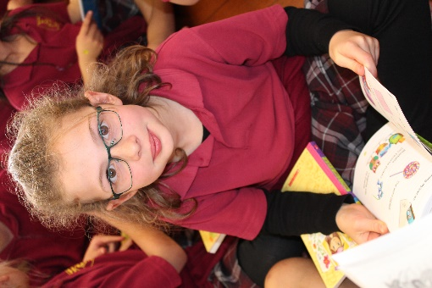As a Duffy School we receive financial support from MAINFREIGHT (NZ) LTD which enable us to provide every child on the roll with four books (of their own choosing) per year.
* We have enjoyed being on the Books in Homes Programmes since 1995 and our major sponsor is keen to continue their support of our children.
* We celebrate with Duffy assemblies at which role models speak to the children about their choices in life. Senior students facilitate these assemblies which are always a highlight for the children.
* Parents are warmly invited to come and share in these celebrations.



**MILK IN SCHOOLS**

C:\Users\cathryn\AppData\Local\Microsoft\Windows\Temporary Internet Files\Content.IE5\TLUXD3X4\MC900363736[1].wmf

* In 2014 we joined the Fonterra Milk in Schools Programme.
* We will be provided with milk each week which will be distributed to the children.
* If you do not wish your child to receive milk please let us know.
* We will have a permission form in our enrolments packs from this year.

**CHOIR**

* Mrs. Rosalie Palmer works with the school choirs. Children choose to take part in this and perform at school assemblies throughout the year.
* **C:\Program Files\Microsoft Office\Media\CntCD1\ClipArt8\j0345358.wmf**The choirs also get the opportunity to perform for a range of audiences throughout the year with a number of concerts at the end of the year as well.

**IF — FOR ANY REASON, YOUR CHILD HAS PROBLEMS AT SCHOOL**

* In the first instance - see your child’s class teacher
* If not resolved, discuss the problem with the Team Leader
* If still not resolved - make an appointment to speak with either the Associate

Principal- Alison Astwood, or Tāmara Simpkins or the Principal – Craig McFadyen.

* In almost every case—the problem goes no further than the person who has most to do with your child his or her class teacher.

**BEHAVIOUR**

We have a number of school-wide systems in place to support school culture and behaviour.

**ONE: FISH**

We recognise positive behaviour and attitude through our fish certificates.

Each child has a fish, in their classroom, with 30 spaces.

Once 30 stickers are received the child receives a certificate from the Principal at assembly. This system acknowledges those children who are making progress, demonstrating achievement, showing a positive attitude; demonstrates our values in their actions and positive behavior role modelling. In this way we acknowledge the vast majority of students who have a good attitude towards their schooling.

**TWO: MAUNGA**

The Maunga is a daily behaviour management challenge for all children. Their goal is to climb the mountain every day and reach the summit. All classes have a maunga/mountain displayed in their class.

All children start at kura/school each day. The idea is to reach the summit every day. They can move up for many different reasons- listening, manners, making good choices…

Each child who reaches the top of the mountain receives a fish sticker at the end of the day.

As always, there are consequences for negative actions.

* Blue- warning. Children have the chance to fix their mistake
* Yellow- timeout in class
* Orange- timeout in buddy class
* Red- sent home

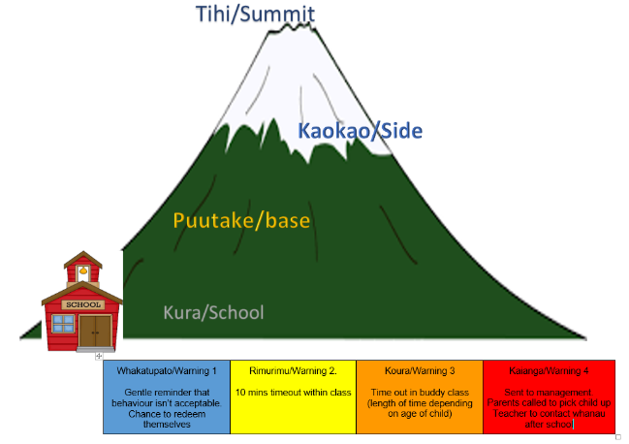

**THREE: GREAT VOUCHERS**

Duty staff have values vouchers which can be completed while on duty. Similar vouchers are also given by shop owners within the community. These vouchers are for recognition of GREAT playground behaviour. Students put the completed value voucher in the large red post box and at each assembly three vouchers are drawn out. The children then receive a school band. There are five to collect which spells GREAT and has the school values on it.

**FOUR: MOVIES WITH Mr. McFADYEN**

At the end of the day, teachers tick the names of all children who have reached the top of the maunga. At the end of the week all children with 3 or more days at the top of the maunga, write their name on a ‘movie slip’ and one child brings all the ‘movie slips’ from their class to the office. Mr McFadyen will randomly draw a name out of the container on Friday afternoon. In the last week of term, he will then take the children (and one other staff member or parent) and go to the movies.

**MISBEHAVIOUR**

For serious incidents ministry procedures will be followed and parents will be kept informed and involved in any action required. Your support for each system is necessary and appreciated so that home and school can work together in partnership to ensure your child enjoys educational success at Ngongotaha School.

Please make contact with your child’s teacher if you ever have questions, positive comments or concerns.

**CELL PHONES**

* We ask that children do not bring cell phones to school. If your child does bring a cell phone to school, please hand it into the office for collection at the end of the day.

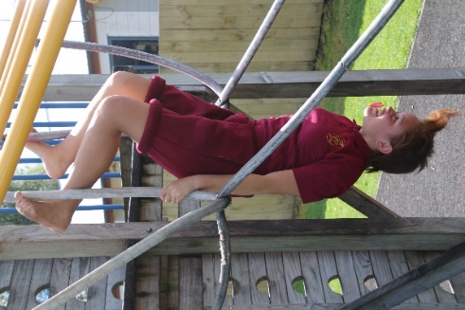**LUNCH RECREATION**

* Staff volunteer to organise sporting, cultural, educational or recreational activities throughout the term. We endeavour to provide activities that develop motor skills, educational achievement, perseverance and a “can do” attitude.
* We have traditional activities along with non-traditional. Children have stilts, unicycles, petanque, croquet, chess and draughts to challenge and motivate them in their free time. These items are changed and rotated regularly.
* It is great to see children supporting and teaching each other, developing social skills and having a go at these activities.
* The school library will be open during some lunch breaks for those children who wish to have extra time in this facility.

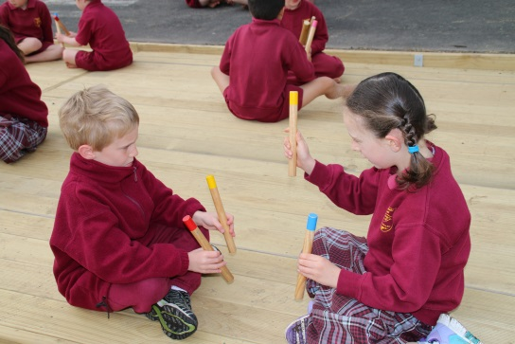

* We have begun a clubs initiative whereby a number of options and activities are made available for children to take part in, during break times. This contributes to social development and promotes a positive playground culture.

**KAPA HAKA**

* Each year a group participates in the annual Rotorua Primary Schools Maori Festival – Ahurei. This is non – competitive and each area of the school gets the opportunity to take part in this festival on a rotation basis.

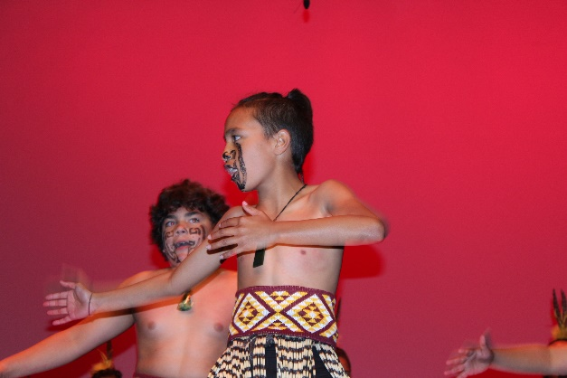

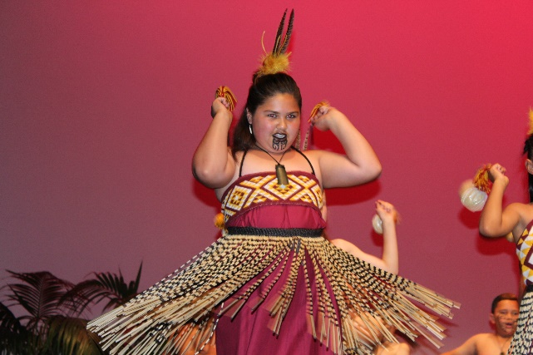

**TRIATHLON OR DUATHLON**

* Each year we hold a non-competitive triathlon at school. Children can take part in this event which is run in school time and widely supported by children and families. The challenge of completing the course is one the children like to take up.

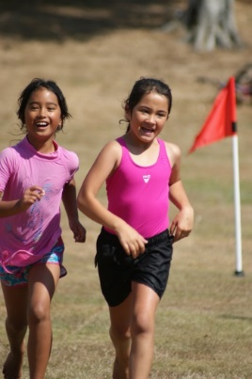

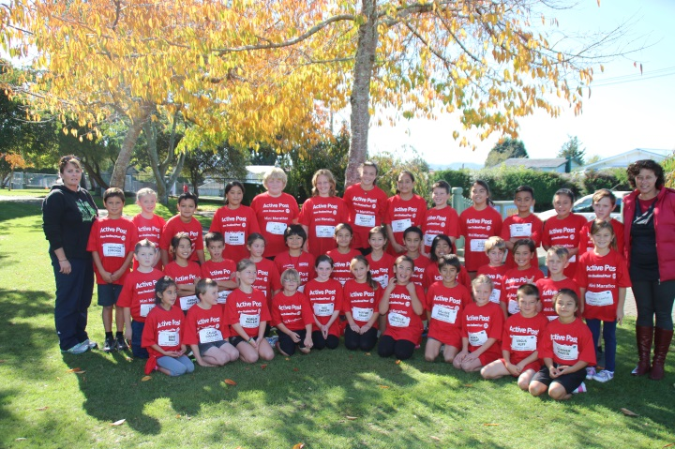

**ROLES AND RESPONSIBILITIES**

* We encourage and provide opportunities for children to take on roles of responsibility. Senior children will be appointed to a range of roles which assist in the development of school culture.
* Some of these roles are: lunch monitors, flag responsibilities, milk monitors, road patrollers, librarians, buddy class representatives, peer mediators, sports equipment monitors, recycling responsibilities and Duffy assembly roles. Each of these roles develops communication, participation, contribution and social skill development and continues to develop a sense of whanaungatanga (sense of belonging).

**FINAL ASSEMBLY – PRIZE GIVING**

* At the end of each year we celebrate the school year with the students. We have a number of awards which are presented at this assembly.

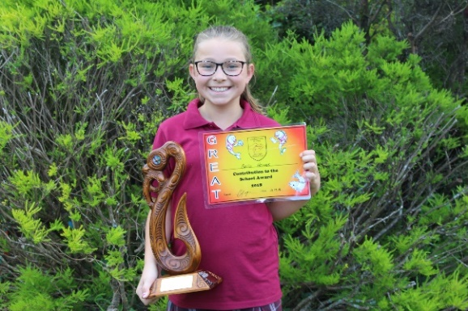

* Each class teacher presents book awards for “Outstanding Citizenship” and “Application to Studies”.
* Trophies are awarded for “Most Promising Sports Year 1 or 2 and Year 3 or 4 Boy and Girl”
* Trophies are presented for “Outstanding Contribution to Sport” Year 5 or 6 Boy and Girl.
* Two trophies are awarded for “Maori Culture” involvement.
* Three trophies are presented for “Excellence in Te Reo”.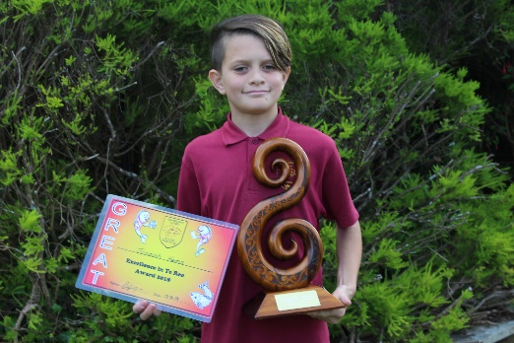 Year 1 or 2, Year 3 or 4. Year 5 or 6.
* Two trophies are presented for “Contribution to the School”.
* Three GREAT trophies are presented for students who exemplify our school values. Year 1 or 2, Year 3 or 4, Year 5 or 6.
* The “Naera Award” for Perseverance
* A Mainfreight sponsored awarded is presented for “Mainfreight Excellence in Attitude”
* The “Kelso Award” is presented to the top all-round Year 6 Boy and Girl

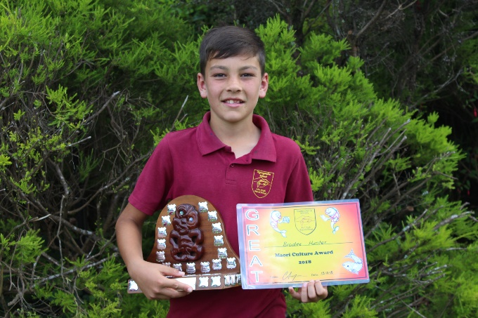

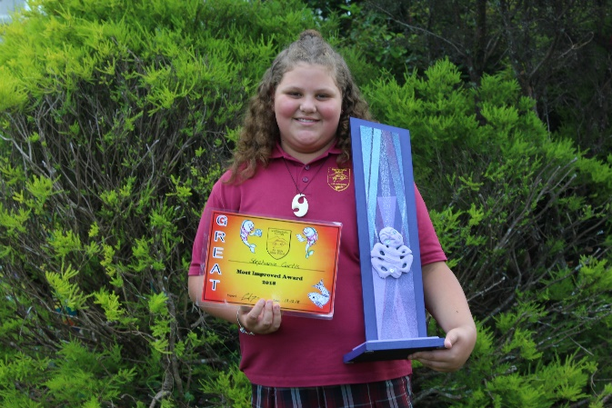

**ENROLMENT ZONE**

From the start of 2018 we have been operating an enrolment zone due to the increase in the school roll.

**NGONGOTAHA SCHOOL (1852)**

**ENROLMENT SCHEME**

**Effective from 29th January 2018**

The guidelines for development and operating of enrolment schemes are issued under section 11G (3) of the Education Act 1989 for the purpose of describing the basis on which the Secretary’s powers in relation to enrolment schemes will be exercised.

**Home Zone**

**All students who live within the home zone described below (and shown on the attached map) shall be entitled to enrol at the school.**

*Starting at 48 Waikuta Road, follow the lake edge northwards to the north-east corner of 406 Hamurana Road (SH36).  From here, travel inland capturing even-numbered properties between 412 and 438 Hamurana Road, to the intersection of Hamurana and Tauranga Direct Roads.*

*Travel north-west along Tauranga Direct Road to the southern boundary of 137 Tauranga Direct Road.  137 Tauranga Direct Road is excluded from the zone.*

*From the southern boundary of 137 Tauranga Direct Road travel west to the intersection of Jackson, Central and Sharp Roads.  All addresses on Sharp Road, and addresses from number 1 to 214 Central Road are included in the zone.  Addresses on Jackson Road are excluded from the zone.*

*The zone travels west from the intersection of Jackson, Central and Sharp Roads capturing all addresses on Anderson Road and Oturoa Road, to number 1089 Oturoa Road.  Addresses on Scott Douglas Drive are excluded from the zone.*

*From 1089 Oturoa Road, the travel south to 948 State Highway Five, then east along State Highway Five to capture even-numbered addresses from 948 to 870 State Highway Five.  At 870 State Highway Five, cross the road to capture 839 State Highway Five, and travel south-east to the railway line where it meets the western edge of 63 Burnsdale Drive.*

*Travel south along the railway to capture 432 and 432A, B and C Dansey Road, then cross Dansey Road to capture 379 Dansey Road.  Continue south to capture 801 Paradise Valley Road, and then further south to 715 Paradise Valley Road.*

*At 715 Paradise Valley Road cross the road to capture 728 Paradise Valley Road, then travel north-east over Mount Ngongotaha (excluding addresses on Mountain Road), to 451 Ngongotaha Road.*

*At 451 Ngongotaha Road, cross the road, capturing addresses to 508 Ngongotaha Road, and continue east across the railway to the boundary of 250 Parawai Road, and then further east  to the lake front.*

**Out of Zone Enrolments**

Each year the Ngongotaha School Board of Trustees will determine the number of places which are likely to be available in the following year for the enrolment of students who live outside the home zone.  The Board will publish this information by notice in a daily or community newspaper circulating in the area served by the school.  The notice will indicate how applications are to be made and there will be a specific date by which all applications must be received.

### Special Programmes

The school operates the following special programme:

* Rumaki - Immersion Te Reo Maori classes, Year 1 to Year 6

Students who live within the school’s home zone and meet the criteria for enrolment in the special programme will be enrolled ahead of out of zone students.

The criteria for acceptance into the programme are as follows:

* Attendance at kohanga reo previous to attending school
* Parent request for this education for their child
* Attendance in rumaki education at previous schools, if not first time enrolments

Applications for enrolments will be processed in the following order of priority:

* **First priority** must be given to students who have been accepted for enrolment in the following special programme(s) run by the school and approved by the Secretary for Education.
* **Second priority** must be given to applicants who are siblings of current students.
* **Third priority** must be given to applicants who are siblings of former students.
* **Fourth priority** must be given to any applicant who is a child of a former student of the school.
* **Fifth priority** must be given to any applicant who is either a child of an employee of the board of the school or a child of a member of the board of the school.
* **Sixth priority** must be given to all other applicants.

If there are more applicants in the second, third, fourth, or fifth priority groups than there are places available, selection within the priority group will be by ballot conducted in accordance with instructions by the Secretary.  Under Section 11G (1) of the Education Act 1989.  Parents will be informed of the date of any ballot by notice in a daily or community newspaper circulating in the area served by the school.

Applicants seeking second or third priority status may be required to give proof of a sibling relationship.

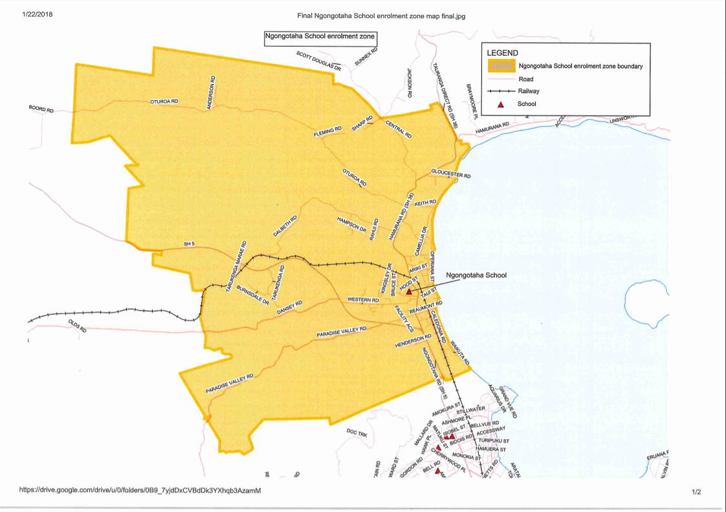

**This table outlines the procedures that are in place for non-attendance at Ngongotaha School - Unjustified Non- Attendance.**

**This procedure is based on Ministry Guidelines**

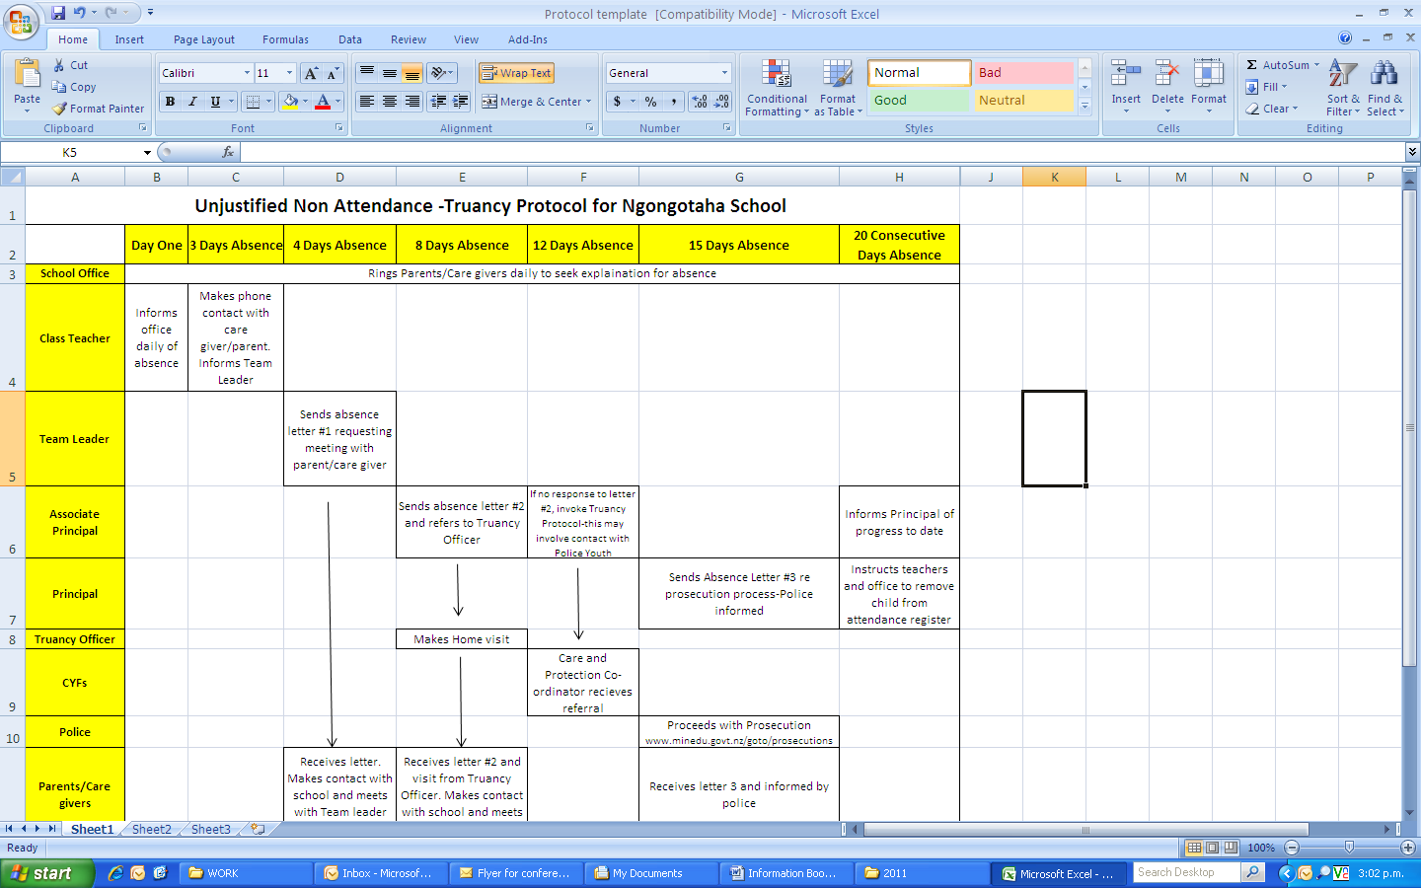

“We look forward to sharing Ngongotaha School with you”.

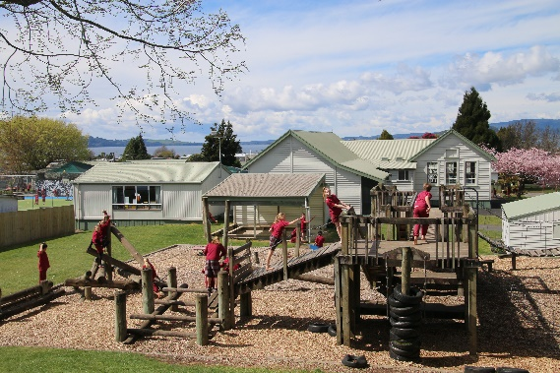

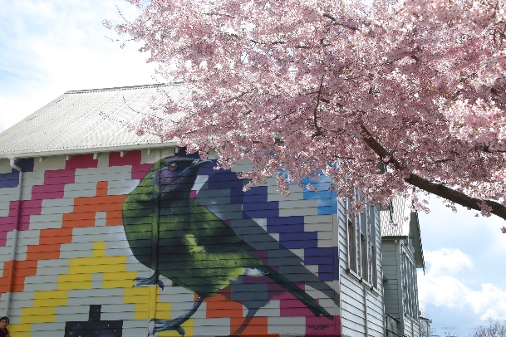

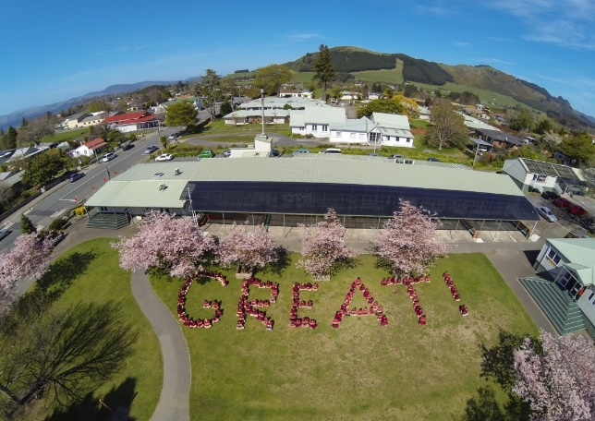

**NOTES OR QUESTIONS YOU MAY HAVE:**